

# Introduction to Systems Analysis Final Report

### CSC 375

________________________________________

**Date:** 3rd Dec 2017

**The Clients:** The UVSS Food Bank and Free Store (Alexandra Dawn and Josie Simpson)

**The Hungry Birds:**

* Chris Zhao
* Devroop Banerjee
* Nelson Dai
* Tariq Chatur
* Wanjin Yu
* Xuyao Qin

**Purpose:**

* CSC375 course requirements
* Summary/Analysis of Food Bank’s current system
* Proposed Solution to Current System’s Problems

# Table of Contents

________________________________________

**Introduction to Systems Analysis Final Report** **0**

**Table of Contents** **1**

**List of Figures and Tables** **3**

**________________________________________**

**Executive Summary** **4**

**Introduction** **5**

1.1. The Clients 5

1.2. The Hungry Birds Team 6

**Current System Overview** **8**

2.1. Current System Description 8

2.2. Use case specifications 9

2.3. Functional requirements 10

2.4. Non-functional requirements 10

**Proposed System** **11**

**________________________________________**

3.1. System Overview 11

3.2. Request for Proposal 12

3.3. Interviews and Surveys 13

3.4. Data Flow Diagrams 15

3.5. Data Dictionary 16

3.6. Pros and Cons 19

Pros: 19

Cons: 19

3.7. Risks and Limitations 20

Risks: 20

Limitations: 20

3.8. High Fidelity Prototype 21

**Recommendations** **24**

**________________________________________**

**Final Thoughts** **24**

**________________________________________**

**Acknowledgements** **25**

**________________________________________**

**Appendix A - Project Charter** **26**

**________________________________________**

Section 1. Introduction 26

1.1 Document Change Control 26

1.2 Exclusive Summary 26

1.3 Authorization 27

Section 2. Project Overview 28

2.1 Project Summary 28

2.2 Project Goals, Outcomes, and Objectives 28

2.3 Project scope 28

2.4 Milestones 29

2.5 Deliverables 30

2.6 Project Risks, and Constraints 30

Section 3. Project Organization 31

3.1 Project Governance 31

3.2 Team, Roles and Responsibilities 31

3.3 Project Facilities and Resources 31

**Appendix B - Weekly Progress** **32**

**________________________________________**

**Appendix C - Alternative Solution** **34**

Daily tracking 34

Real-time tracking 34

**Glossary** **35**

**Index** **37**

**________________________________________**

# 

# 

# List of Figures and Tables

# ________________________________________

Fig. 1.1. Alexandra Dawn

Fig. 1.2. Josie Simpson

Fig. 1.3. Chris Zhao

Fig. 1.4. Devroop Banerjee

Fig. 1.5. Nelson Dai

Fig. 1.6. Tariq Chatur

Fig. 1.7. Wanjin Yu

Fig. 1.8. Xuyao Qin

Fig. 2.1. Food Bank Tracking Sheet

Fig. 2.2. Use Case Diagram

Fig. 3.1. Letter of Agreement

Fig. 3.2. Food Bank Users Survey

Fig. 3.3. Client interview

Fig. 3.4. UML Diagram

Fig. 3.5. Context Diagram

Fig. 3.6. Level 0 Diagram

Fig. 3.7. Log-in Page

Fig. 3.8. Tracking Page

Fig. 3.9. Daily Update Page

Fig. 3.10. Previous Logs

Fig. 3.11. Statistics

# 

# 

# 

# Executive Summary

________________________________________

Our project is based on the current system used by the UVSS Food Bank and Free Store and how it could be improvised to eliminate the issues faced by our clients on a daily basis. One of our team members is a volunteer at the Food Bank. Since he already had some background knowledge on the food bank’s system, we decided to progress with our efforts to work with them. Thankfully, the coordinators (Alexandra Dawn and Josie Simpson) were very cooperative and helped us as much as they could with anything we required..

The Food Bank’s current system is a paper based, Microsoft Excel-like grid where every user of the Food Bank is required to write down their student number and fill out the amount of goods taken in their respective fields. This is confusing, time consuming, ineffective and it also wastes resources like paper and physical space (The food bank is a small room which is crammed up as it is).

Our elite team of sleep-deprived-science-kids have a solution for this. We focused on simplistic UI and minimal changes from the original design, while solving the main problem at hand, ie: tracking inventory. The digitized system we proposed, would require the volunteers to simply type in the user’s student number, update the latter’s status (grad/undergrad/single/family) and the inventory on (a) daily basis and (b) in case of a food delivery. This program has the option to download or print previous logs (which can be searched by date). We also implemented a log in/out system for security purposes.

Alternatively, we could have made a system which supports real-time tracking which sounds like a better, more detailed idea; it’s really not. It would take time for the users to figure out how to use said system. Besides, Listing each item and the quantity taken, individually bring us back to the issue of time consumption and inefficiency.

Luckily, our clients found a programmer (Henry) who agreed to work with us to make this project a reality. We spoke to him and explained our solution to him. Henry believes that he can make this program using MySQL, but he can start after the semester ends. He will donate a laptop (with a functional copy of the program) to the food bank and maintain it for the next three years, after which he graduates. Let’s take a more in-depth look at the current and proposed systems to help you better understand what we’re talking about.

# Introduction

________________________________________

## 1.1. The Clients

Our client is The UVSS Food Bank and Free Store which is located in the Student Union Building at the University of Victoria. The UVSS Food Bank and Free Store is a non-profit organization which is organized by Uvic’s Student Society (UVSS). The food bank provides free food and household items to current students at University of Victoria. The food bank accepts donations from students and other social organizations and/or individuals. Basically, UVSS Food Bank and Free Store is a platform for people to donate and get food and/or items. The staff are all volunteers.



Currently UVSS Food Bank and Free Store is lead by two volunteers. They are Alexandra, who is the coordinator and Josie, who is the assistant coordinator. They are in responsible for all the numerous aspects of the management. Like their inventory, the facility runs on donations and limited budgeting from UVSS. The volunteers can take up as many shifts, as they like, throughout the week. The volunteers get a complimentary cup-of-coffee card (which doesn’t affect their limited budgeting).

The standard recording process of the current system at the food bank is that when a user comes to the food bank, one of the volunteers will ask his/her student ID and record it. Then the user grabs some food or items and the volunteers check what the user gets and write them on a piece of paper. The record will be checked later, in order to track the inventory. Also, when donations come in, it follows the same process as above. All of the records are kept on paper.

## 1.2. The Hungry Birds Team



**Name:** Chris Zhao

**Age:** 23

**Experience:** Bachelor of Computer Science at the University of Victoria (ongoing)

**Future plans:** Software developer, front end developer



**Name:** Devroop Banerjee

**Age:** 20

**Experience:** 4th year Computer Science major with a minor in maths at the University of Victoria. Leadership roles in previous team projects, programmer, previous knowledge about systems analysis from a HCI course.

**Future plans:** I intend to further my education and get a job as a programmer/analysts/designer after my Masters.



**Name:** Nelson Dai

**Age:** 23

**Experience:** 4th year computer science student.

**Future Plans:** Web development and making phone apps.



**Name:** Tariq Chatur

**Age:** 20

**Experience:** 3rd year Computer Science Major at the University of Victoria. Experience with Inventory management through Restaurant Management and Delivery Work.

**Future plans:** Working in Japan or Canada for a Graphics Company, develop a backend system to handle the business model for my father’s restaurant.



**Name:** Wanjin Yu

**Age:** 22

**Experience:**  4th year computer science student at University of Victoria, Attended Hack-A-Thon in 2016.

**Future plans:**  I am willing to get a job at web development company and planning to attend grad school later on.



**Name:** Xuyao Qin

**Age:** 24

**Experience:** 4th year computer science student at the University of Victoria, transferred from electronic engineering.

**Future plans:** Start career on hardware configuration, server establishing, and maintenance

# Current System Overview

________________________________________

## 2.1. Current System Description

The way their current system functions is that users come to the food bank, collect what they need, and fill up a “tracking sheet” provided on the desk to track daily inventory. Papers are stored in the wooden cabinet in the room. The coordinator will calculate the monthly and yearly usage, manually, based 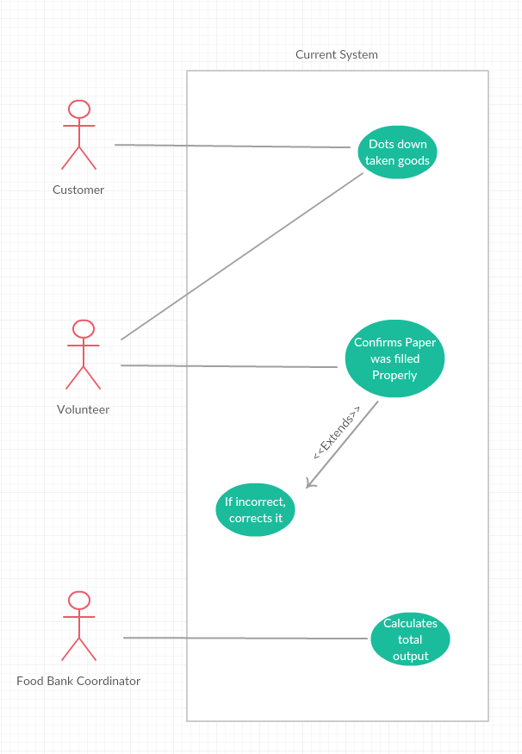

on those inaccurate tracking sheets. The Food Bank’s current system meets all of our client’s needs in theory.

The users of the food bank are UVic students, currently enrolled in courses. They are supposed to come once a week but usually none of the students do. They come as and when they need something and roughly take the quantity allotted to them, but with the change in shifts of volunteers and inaccurate tracking, who knows how much food is taken.

### 



## 

## 2.2. Use case specifications

### Case 1

**Name:**Dots down taken goods

**Actors:**Customer, Volunteers

**Preconditions:** There is food at the food bank and the customer has a VNumber

**Steps:**

* Count how many items the customer takes
* Write down the number of items

**Success condition:**The number of items taken is recorded on the paper

**Alternative path:** None

### Case 2

**Name:**Confirm Record is filled properly

**Actors:**Volunteers

**Preconditions:** Customer has finished taking goods and filling the record

**Steps:**

* Check the content that customer filled in the record and compare with the items the customer has

**Success condition:** The record has been confirmed and updated correctly

**Alternative path:** None

### Case 3

**Name:** Compute Total Output

**Actors:** Food Bank Coordinator

**Preconditions:**The previous in and out records and handed to the coordinator properly  
**Steps:**

* Compute the monthly inventory flow based on existing records
* Match the flow with the current inventory stock

**Success condition:** The inventory stock matches the total output flow

**Alternative path:** None

Since the current system is paper-based, we looked deeper into the printing costs and found that it was negligible. The interaction time for a single user to fill up the tracking sheet is around a minute or two. It is longer for those who are visiting the food bank for the first time. Despite having the volunteer help them out, users might take time to get acclimated to the system. Also, since the system is run by volunteers who come from a variety of different disciplines and might not be tech-savvy, it would need to be user friendly. Being a non-profit organization, the food bank’s budget is tight.

Other obvious problems that follow a paper-based system would be the physical loss, damage or theft of data. Now all of these can be done to a softcopy of the data too. However, our system is secure and offline. Hence, all the data is stored on the laptop’s in-built hard disk.

Another issue with the current system is interaction time. When users record data on the paper, it takes a while to finish filling it out. For this reason, it is also important to make a system that has a short interaction time. The laptop’s hardware specifications are definitely a major factor here, but our programmer claims that he has augmented his laptop recently. Thereby, the system itself will not hang and take long to respond. Instead the interaction time would be dedicated mostly to the time taken by the volunteer to type and click buttons.

Considering how cluttered and confusing the tracking sheets are, it is inevitable that the users of the food bank would put the right quantity in the wrong row or tick “family” instead of “single”. It would be logical to make a system which interacts not with the users, but with the volunteers instead. The volunteers are less likely to make errors, especially if they have to update the inventory just once. Sometimes, the food bank gets lucky and receives large, unexpected donations. The current system expects the volunteers to accept and reshelf/store those donations. The proposed system is prepared for beautiful anomalies such as this.

## 2.3. Functional requirements

The purpose was to track the total amount of food taken, and notice the trends in the demands of certain food items. With this information the food bank would be able to redistribute the budgeting to buy more of the things people want, while correcting any unnecessary waste. Furthermore, they would have empirical evidence to support requests for specific items, and provide reason for additional funding.

## 2.4. Non-functional requirements

The coordinators were clear with their intentions, ie:- they only wanted to observe and know who could have taken extra food but not say anything about it because there’s a reason they are doing it. This means a little inaccuracy for the sake of a simpler system was feasible which was a big win because the volunteers would not have much time to study it. However, let’s say they volunteers do have a hard time figuring the system out and accidentally lose data. The system should have a way to recover the data or backup the data in multiple locations. Lastly, what’s a system without security? To make the data accessible only to the volunteers/coordinators, the program needs a log in/out system.

# Proposed System

# ________________________________________

## 3.1. System Overview

In order to solve the problems from the current system, our team has decided to build a digital inventory management system. The system records the visitor’s student number for each visiting. Detailed information for transactions are not recorded due to the client’s needs. Inventory information is updated by the morning shift with available delivery invoices. Outgoing good list is calculated by subtracting two day’s worth of inventory information.

The cost of operating is significantly reduced by our design because:

1. The new system is completely computer-based which makes printing paper unnecessary (although there is an option to print)
2. The food bank has received a laptop as donation which minimizes the cost for the new system hardware purchases.

Safety and security is maintained by leaving no hard copies or online copies of the food bank’s data outside of BC. Moreover, the data is not only stored on the local hard disk, but also on the uvic email server which prevents data losing or damaging from accidents.

Operating efficiency is another improvement with our new system. Unlike the current system, which requires each visitor's interaction, our new system is designed for staff members (volunteers) only. The volunteers are responsible for requesting the user for their student number (to update the visitor’s table), updating the inventory if they’re the first volunteer of the day or if there is a delivery. This largely improves the reliability of the tracking data as well as reduces the interaction time.

## 3.2. Request for Proposal



## 

## 

## 3.3. Interviews and Surveys

## 

## 

## 

## 

## 

## 

## 

## 

## 

## 

## 3.4. Data Flow Diagrams

## 

## 3.5. Data Dictionary

## 

|  |
| --- |
| Transaction:  Item Name +  Total + |
| Date:  Date + |

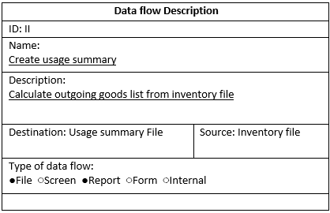

|  |
| --- |
| Outgoing:  Item Name +  Total + |
| Date:  Date +  Time + |

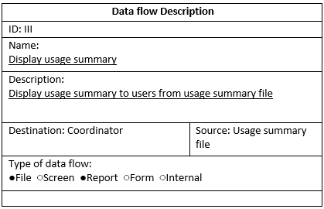

|  |
| --- |
| User Name:  First Name +  Last Name + |
| User ID:  V-number + |
| Usage Summary:  Item Name+  Item ID +  Date +  Time + |

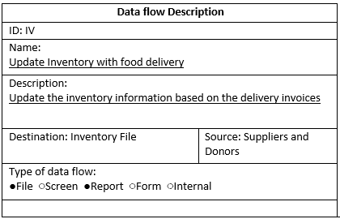

|  |
| --- |
| Transaction:  Item Name +  Item Total + |
| Doner :  Donor Name +  Donor Type + |
| Donation Time:  Date +  Time + |

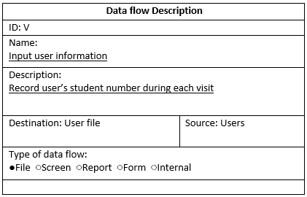

|  |
| --- |
| Student:  Student Name +  Student Number + |
| Time :  Date +  Time + |

## 

## 3.6. Pros and Cons

### Pros:

* **Discoverability** - The buttons and functions are easily discoverable throughout the program
* **Learnability** - The design is easy to learn after using it a few times
* **Memorability** - It can be recalled/memorized quite easily
* **Affordances** - The system clearly indicates what it is capable of doing and what the system is not, eg:- it can afford to print logs, but there’s no option to share log via email
* **Signifiers** - Each object in the program is clearly signified by whether it is intractable or not
* **Constraints** - Reinforces the idea of affordances. Constraints on what the system can/can not do
* **Mappings** - The objects which are related to each other, are located in close proximity to indicate mappings between functions of objects.
* **Consistency** - The design, functionality, location and appearance of content stay consistent throughout the different pages of the program to maintain consistency for easier learnability and memorability
* **Security** - The log in/out system to prevent anyone other than registered volunteers of the system to break in
* **Data Recovery** - Data archives in Uvic’s personal servers to recover any loss in data

### Cons:

* **Human errors** - The accuracy of inputted data depends on the volunteer
* **Hardware problems** - Hardware malfunctions are time consuming and expensive

## 3.7. Risks and Limitations

### Risks:

* Potential High costs in equipment replacement
* Invoices are lost or damaged before being inputted
* All volunteers have access to data storage and authentication (could have been avoided if the coordinators were the first volunteers of the day, everyday or if the passwords were changed monthly)

### Limitations:

* Data has to be stored in a server inside of BC
* Non profit organization; therefore, equipment must be cheap or free
* Software malfunctions will be handled slowly if at all, due to lack of customer support

## 

## 

## 3.8. High Fidelity Prototype

Link: <https://devroopbanerjee.proto.io/player/index.cfm?id=11390955-02e6-4979-ab99-3c41ba86ae87>

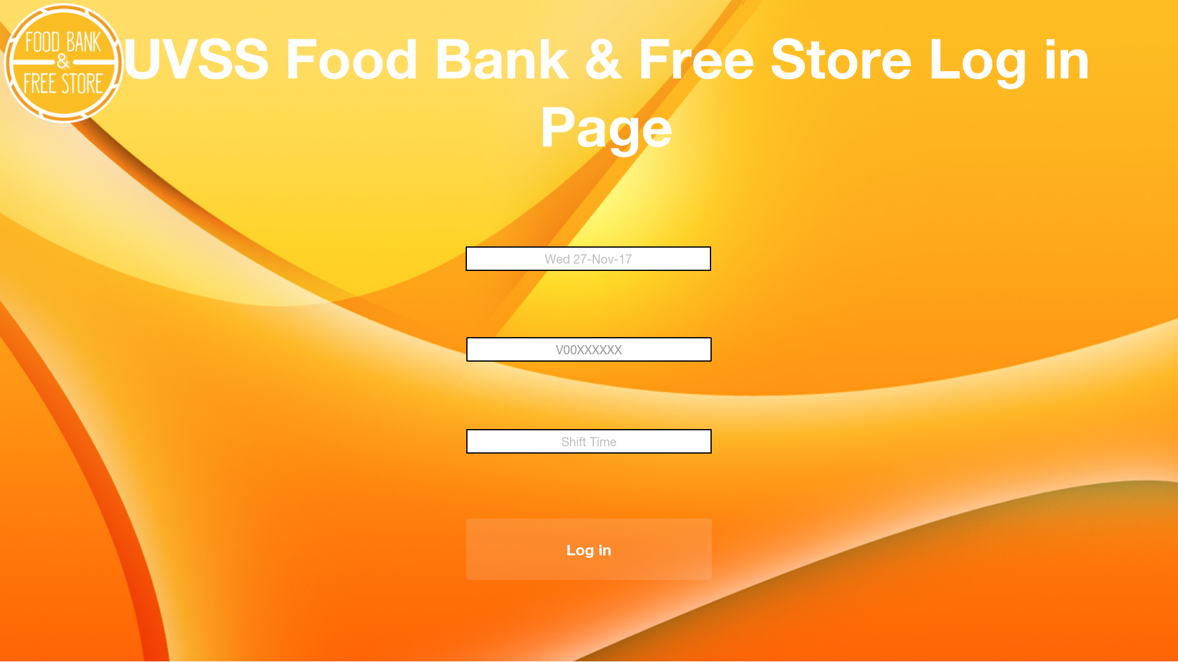



The following is a picture of the default “Log-in” page where the volunteer can input the date, their student number and the time their shift begins. If the student number entered does not match with one of the registered student numbers (ie: the list of all the student numbers of the volunteers), the user would be denied entry.

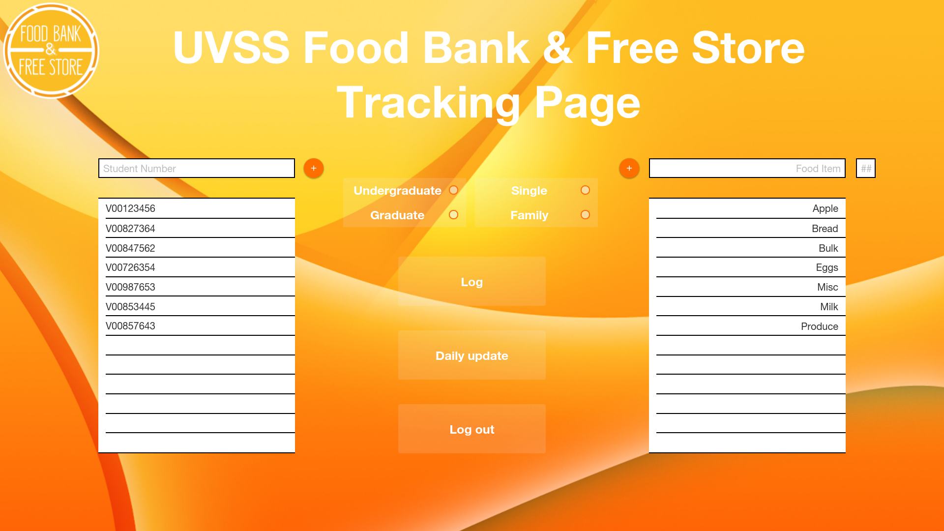



After the volunteer logs in, they are greeted by the “Tracking Page” which is essentially the home page for this program. The volunteer asks the user for their V number, whether they are undergrad/grad and whether they are supporting a family or not (double the quantity of food for a family). The volunteer now adds the user to the list of student numbers already in the visitor’s table. That is all the information that is needed from a user of the food bank.

If the food bank receives a food delivery that day, the volunteers input the data into the boxes on the right and update the quantity. Since donations and/or deliveries can get random sometimes, this option to update has been kept on the tracking page. A more robust version of this can be accessed by clicking on the “Daily Update” button. This is where the volunteer should be if they are the first person to volunteer that day.

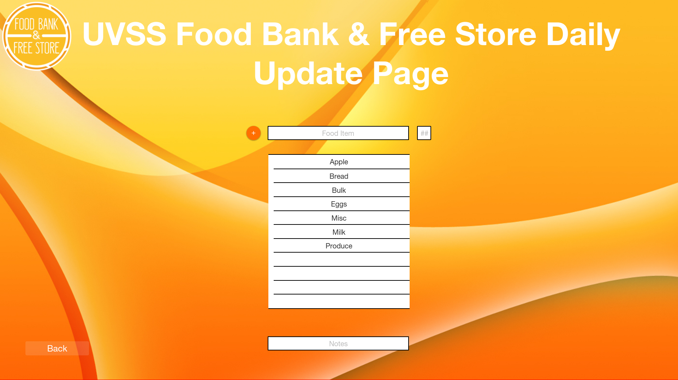



The “Daily Update” Page is simple. The volunteers check the quantity for each item at the beginning of the day. They type it in the box at the top along with any important information for that item in the textbox below eg:- any updates in delivery schedule or no more supply, etc. Clicking the back button/ the food bank logo in the top right corner takes the volunteer back to the tracking page.

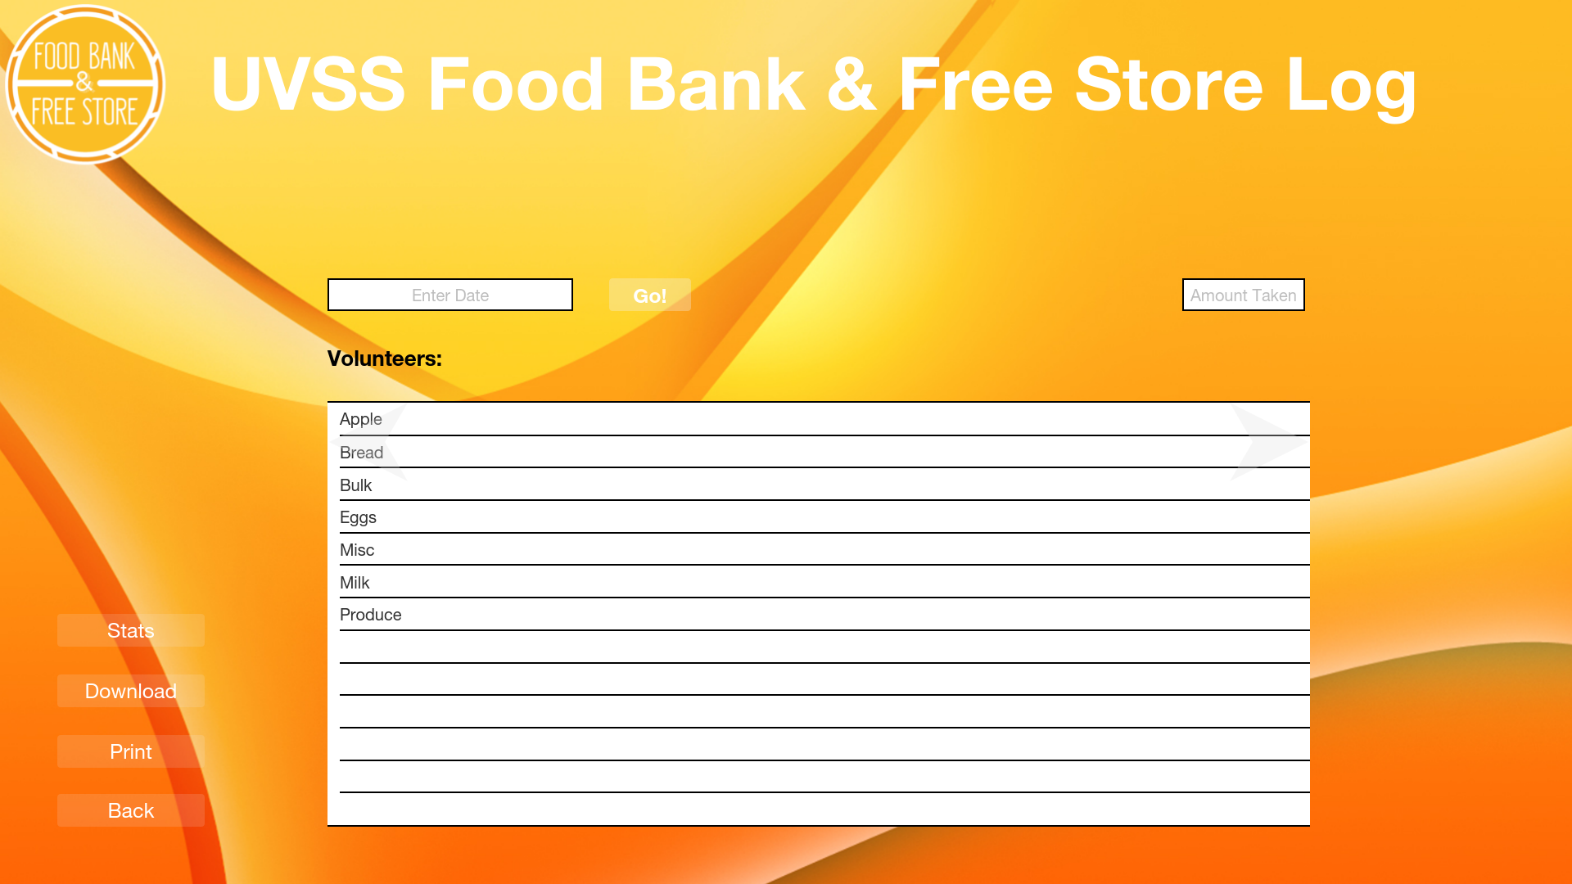



Clicking the “Log” button on the tracking page would take us to a screen as shown on the right. The volunteer can type in the date and click “Go!” pull up records from that day (this displays the volunteers from that day as well). Clicking on an item in the list will display the quantity remaining at the end of that day. Clicking “Download” would download an excel version of the records from the day specified. Clicking “Print” would take you to a default print screen (try clicking them in the prototype). The “Back” button and the food bank logo returns the volunteer to the tracking page again. However, the “Stats” button shows something interesting.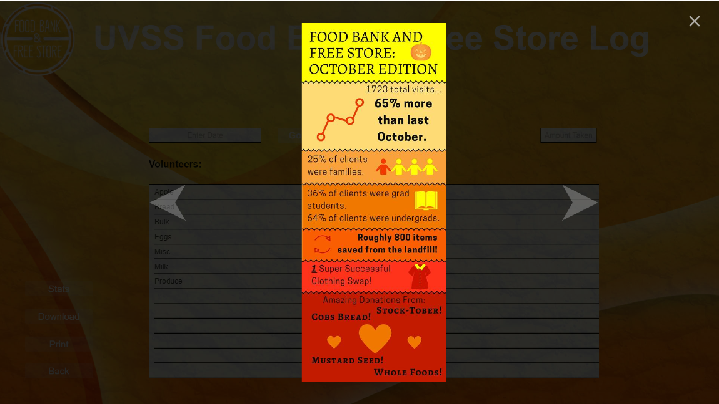

The “Stats” button allows the volunteer to view the statistics and trend in the consumption of food items over a period of time.This would aid the coordinators with figuring out which item to order more of or if there’s an anomaly or strategize better, etc.

“Download” Button:

<https://docs.google.com/spreadsheets/d/1XsMb9F09MR0OINukp8zwqDbu4zq6i2r_cAR_PeWKpzI/edit#gid=0>

“Print” Button:

<http://whatsnew.mastercam.com/2017/images/general/printtab.png>

# Recommendations

# ________________________________________

Our team has provided several recommendations based on the problems we have discovered previously.

**Reducing Human Errors**

In order to reduce the mistakes made by the volunteers, coordinators can assign morning shifts to responsible volunteers to update inventory. It is also a good idea to emphasize on the risk during the training.

**Recovering from a Crash**

Having a copy of program and the data stored stored on a backup drive will greatly reduce the recovery time. Also, The UVSS Food Bank has funds to replace the laptop every 2 years which is shorter than the lifespan of most laptops.

**Switching over to the System**

Although the system we proposed is quite simple, we would still want our users to be comfortable with switching over from the older system. Hence keep a copy of the tracking sheets around and let the users fill up the tracking sheet while volunteers observe and use the program. Take a week to transition over and calculate the increase in accuracy.

# 

# Final Thoughts

# ________________________________________

As a university students, I can comprehend why the food bank is important to so many. Although I only went there a few times, it saved me from starving when I had no money in my pocket. As a student, money is always an issue to us, I can’t explain how glad and grateful I am to have it in our university. I would be happy to see the food bank getting the upgrade it needs to help as many people as they can.

Budget is always one of the most important attributes to consider in a project. In the early stage of the design phase, we came up with numerous ideas to improve the food bank inventory management system in terms of efficiency, durability etc. However, since our client is a non-profitable organization, we had to minimize the cost due to the limited budget. Balancing cost seems to be manageable in our project, but it could be much more challenging in bigger projects.

I was quite disappointed by the lack of motivation and productivity in some of the team members. The work was unequally distributed and some were not bothered despite continuous calls for aid. Either way, if we were more disciplined and enthusiastic about working together as a single unit rather than being motivated by marks, we would have accomplished a lot more, a lot quicker. But all that aside, I enjoyed working with the students I did.

# Acknowledgements

# ________________________________________

Our team would like to express our gratitude and appreciation to Alexandra, Josie, Henry and all the other volunteers of UVSS Food Bank and Free Store for their trust, cooperation, and affiliation with this project.

# Appendix A - Project Charter

# ________________________________________

## **Section 1. Introduction**

## **1.1 Document Change Control**

## 

## **1.2 Exclusive Summary**

**Project name:** Advanced inventory management system

**Client name:** The UVSS Food Bank and Free Store

**Requirements:** A solution which is able to replace their current inefficient and inaccurate inventory recording system (A solution current paper based recording system's data loss issue)

**Stakeholders:** Management staff of UVSS Food Bank and Free Store, project design and development team

**Main user:** Staff of UVSS Food Bank and Free Store

**Project scope:** New inventory record input and output, Inventory information update

**Objectives:**

* Designing and developing an electronic inventory management system to replace the current inefficient and inaccurate paper based system.
* Achieving capability of inventory management system's daily update
* Getting rid of the date loss problem

## **1.3 Authorization**

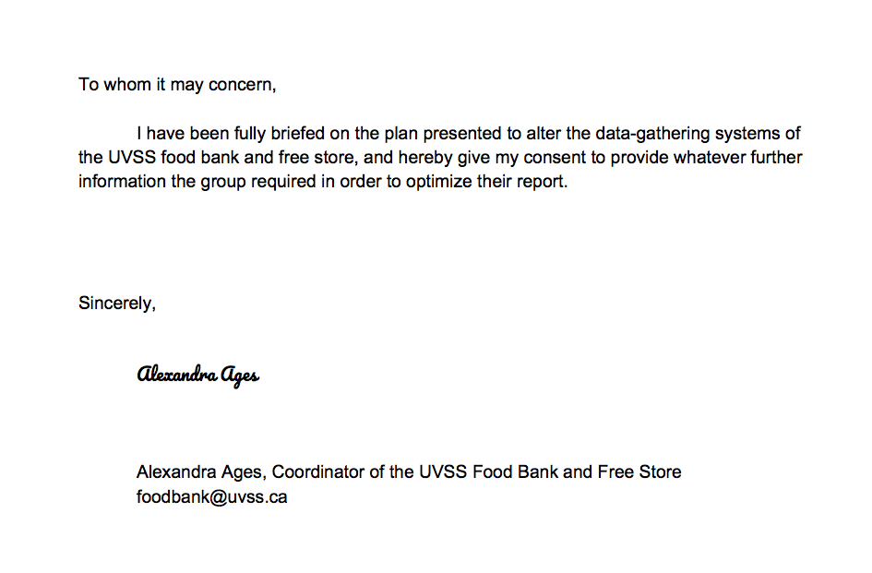

_______________________ *_________*

Tariq Chatur 03/12/17

TariqChatur

_______________________ *_________*  Xuyao Qin 03/12/17

XUYAOQIN

_______________________ *_________*

Devroop Banerjee 03/12/17

Devroop

_______________________ *_________*

Wanjin Yoo 03/12/17

**WanjinYoo**

_______________________ *_________*  Chris Zhao 03/12/17

**ChrisZ**

_______________________ *_________*  Nelson Dai **Hongyu Dai** 03/12/17

## **Section 2. Project Overview**

## **2.1 Project Summary**

The food bank is a non-profit Organisation located in the basement of the SUB, aiming to provide all UVic students with regular and reliable access to food staples and free household items. This project is a chance for our team to improve the food bank’s inventory management system.

## **2.2 Project Goals, Outcomes, and Objectives**

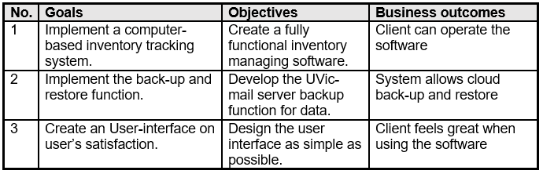

## **2.3 Project scope**

**Functional Requirements:**

* Input Daily Inventory Information
* Input Delivery Information
* Input User Information
* Request Usage Summary

**Non-Functional Requirements:**

* Easy to learn - Any university student should be able to understand how it works in 10 minutes
* Ease of data recovery - Data is stored on both disk and on UVic’s private email server
* Authentication - Only volunteers have access

**Boundaries:**

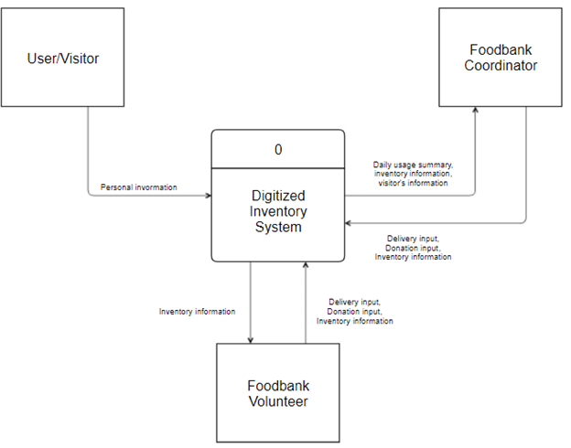

## **2.4 Milestones**

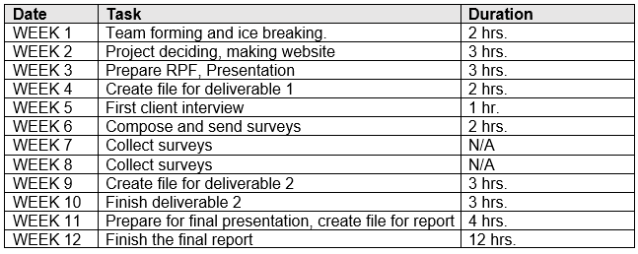

## **2.5 Deliverables**

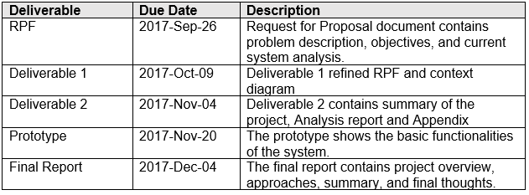

#### **Deliverable 1**

#### <https://docs.google.com/document/d/15cs_N5ik2h2yFJDPraEjoj-1vcUZvBAnAONKM-RDCQY/edit?usp=sharing>

#### **Deliverable 2**

#### <https://docs.google.com/document/d/14KxQJEJfKvwXeMmdrvjX_6EnLEzPMeoCUa3-Prcw5dM/edit?usp=sharing>

## **2.6 Project Risks, and Constraints**

**Risks**

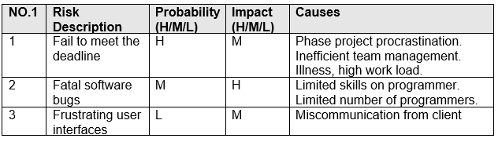

**Constraints**

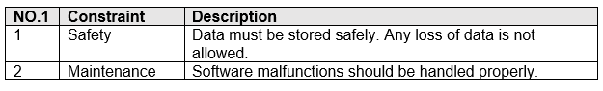

## **Section 3. Project Organization**

## **3.1 Project Governance**

Our team has been established as a two level governance. As our team consisted of 6 students with a similar skill set, the levels naturally established through the two members who interacted with the clients and edited. While all members were able to provide input to the project’s content and processes, the higher level generally filtered which ideas would be executed. All five members contributed to the completion of documents, presentations, and meetings. Though work was not distributed evenly between levels each member was able to work off their strengths whether it be formatting, public speaking, or brainstorming. Because of this level of authority, our team benefited in the long term.

## **3.2 Team, Roles and Responsibilities**

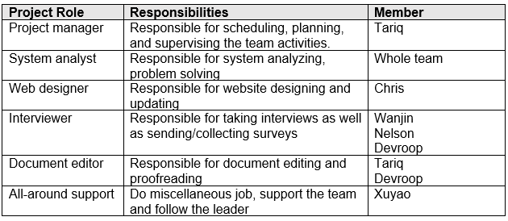

## **3.3 Project Facilities and Resources**

* **Ecs drop-in lab**

90% of the team meetings are done in the drop-in lab located at ECS building. With the access to the lab computers, we could work as a team with high efficiency.

* **Google Doc**

All of our documents are created and stored on google doc since it allows online collaboration.

* **Facebook messenger**

Our team used messenger as the communication tool during the entire project.

# 

# Appendix B - Weekly Progress

# ________________________________________

**Week 1:**

* Nelson formed the team

**Week 2:**

* Website created
* Project decided
* First group meeting (4 hours)

**Week 3:**

* RFP
* Presentation
* Online collaboration (5 hours)

**Week 4:**

* Deliverable 1 begins
* Weekly Meeting (6 hours)

**Week 5:**

* First user interview
* Weekly Meeting (3 hours)

**Week 6-7:**

* Online collaboration
* Completion of staff and user surveys

**Week 8:**

* All members prepare for midterm, project suspended

**Week 9:**

* Deliverable 2 begins
* Final system analysis
* Completion of design documents
* Weekly Meeting (3 hours)

**Week 10:**

* Deliverable 2 finished
* Weekly Meeting (7 hours)

**Week 11:**

* Weekly group meeting (4 hours)
* Slideshow and script are made

**Week 12:**

* Final report finished via online collaboration
* Weekly Meeting (3 hours)

**Project Website:** <https://sites.google.com/view/csc375foodbankproject>

**Gantt Chart:**

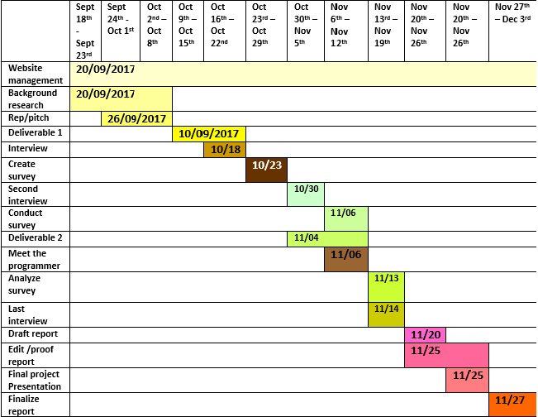

# Appendix C - Alternative Solution

________________________________________

Based on our case studies and research on similar systems, the conclusion we came to was that real time and daily tracking were two most commonly used tracking methods. Each have their pros and cons but Daily Tracking seemed like the more efficient and feasible option in our situation.

## **Daily tracking:**

### **Pros:**

* Easier to implement
* Less training needed
* Low cost of maintain
* Update at certain time periods

### **Cons:**

* No capability of detailed user information recording
* No capability of automatic recording of third party donation

## **Real-time tracking:**

### **Pros:**

* Immediate information tracking
* Capability of detailed user information recording
* High data accuracy

### **Cons:**

* High cost of maintenance
* Difficult to train users regarding all the functionalities that are possible from real time
* More time and labour required

Our original design was to use “Google Sheets” as an easy-access, low-cost, real-time tracking system. After our first presentation, we were informed that Google Sheets is not an option that’s available to us. Data that belongs to UVic must remain within BC. Unfortunately, the online servers for Google Sheets are located in USA. Therefore, we came up with a new solution, independent of our previous idea yet just as effective.

# Glossary

________________________________________

|  |  |
| --- | --- |
| **Term** | **Definition** |
| **Appointment** | An arrangement to meet someone at a particular time and place. |
| **Back-End System** | Back end systems are corporate systems that are used to run a company such as systems to manage orders, inventory and supply processing. Back end systems support the company's back office. This system collects input from users or other systems for processing. |
| **Cup-of-Coffee Card** | A card given to volunteers of the Food Bank for volunteering. The volunteer must bring this card and their own cup to get a free cup of drip coffee. |
| **Database** | A structured set of data held in a computer, especially one that is accessible in various ways. |
| **Digitize** | Convert (pictures or sound) into a digital form that can be processed by a computer. |
| **Email** | Messages distributed by electronic means from one computer user to one or more recipients via a network. |
| **Front End Developer** | A front-end developer is a type of computer programmer that codes and creates the visual front-end elements of a software, application or website. He or she creates computing components/features that are directly viewable and accessible by the end user or client. |
| **Google Sheets** | Google Sheets is a Web-based application that allows users to create, update and modify spreadsheets and share the data live online. |
| **Hack-A-Thon** | An event, typically lasting several days, in which a large number of people meet to engage in collaborative computer programming. |
| **HCI** | HCI (human-computer interaction) is the study of how people interact with computers and to what extent computers are or are not developed for successful interaction with human beings. |
| **MySQL** | MySQL is an open source relational database management system (RDBMS) based on Structured Query Language (SQL). |
| **Online** | Controlled by or connected to another computer or to a network. |
| **Real Time** | Relating to a system in which input data is processed within milliseconds so that it is available virtually immediately as feedback, e.g., in a missile guidance or airline booking system. |
| **Software Developer** | A software developer is a person concerned with facets of the software development process, including the research, design, programming, and testing of computer software. |
| **Student ID (V number)** | An ID of the form “V00XXXXXX” which every UVic students has. |
| **SUB** | Student Union Building. Location of the client. |
| **Tracking Sheet** | A grid-like sheet, filled out by users of the food bank to record the quantity of food taken. |
| **UML** | Unified Modeling language is a standardized modeling language enabling developers to specify, visualize, construct and document artifacts of a software system. |
| **Use Case** | In software and systems engineering, a use case is a list of actions or event steps typically defining the interactions between a role (known in the Unified Modeling Language as an actor) and a system to achieve a goal. The actor can be a human or other external system. |
| **UVSS** | University of Victoria Students Society |
| **Volunteers** | The students who freely offer to take shifts at the food bank |

# 

# 

# Index

# ________________________________________

**A**

Acknowledgements, 21

Affordances, 17

Alexandra Dawn, 5

Alternative-Solution, 34

Analysis, 32

Appendix, 26,32,34

Appointment, 35

Authorization, 27

**B**

Back-end-programming, 35

**C**

Case, 17

Client , 6,9

Cons , 19,20

Constrain, 19,30,31

Cup-of-coffee card, 6,35

Current System, 9

**D**

Daily Tracking, 34

Database, 35.36

Data dictionary, 17

Data Flow Diagram, 16

Data Recovery, 20,28

Delivables, 30

Digitize, 35

Discoverability, 19

**E**

Email, 12,19,28,35

Executive Summary, 5

**F**

Final thoughts, 24

Food Bank Tracking, 4

Front-end-developer, 7,35

Functional Requirements, 11,28

**G**

Gantt chart, 33

Google sheet, 34,35

Glossary, 35

**H**

Hardware, 8,11,12,20

HCI, 36

Human error, 20,23

Hungry Birds, 1,7

**I**

Interaction Time, 10,11,12

Introduction, 1,2,6,26

Inventory, 5,6,7,9,10,11,12,23,24,26,27,35

**J**

Josife Simpson, 4,5,6,25

**L**

Learnability, 19,20

Limitations, 21

**M**

Maintenance,8,34

MySQL, 36

**N**

Non- Functional Requirements, 10,27

**O**

Online, 11,31,32,34,35

Operating Efficiency, 11

Overview, 1,2,8,11,27

**P**

Project Charter, 25

Project Governance, 30

Project Scope, 26, 28

Project Website, 25, 27

Pros, 18, 33

Prototype, 19, 22

**R**

Real-time tracking, 4, 33

Recommendations, 22

Request for Proposal, 12

Risks, 19, 29

**S**

Safety and Security, 12

Statistics, 22

**T**

Training, 23,34

**U**

Use Case Diagram, 9

Use Case Specification, 10

User Survey, 14

UVSS, 5, 6, 36, 40

UVSS Food Bank, 6, 24, 25, 26

**V**

Volunteer, 5, 6, 9, 10, 11, 12, 20, 21, 22, 23, 24 ,25, 28,36

**W**

Web development, 7,8

### 